The Sundays of Summer

Remembering …
Sunday, July 5, 10:30 a.m.
As we begin the first full month of summer, we share bread and wine and remember God’s promises in Jesus Christ … for life
(I Corinthians 11:17-26). We thank Helen Lowe for playing the organ this morning.

The Rev. Ralph Kendall
Sunday, July 12, 10:30 a.m.
We welcome Ralph to the pulpit, as he explores ‘Is that really in the Bible?’ (Esther 1:1-22; Matthew 5:38-48; 2 Timothy 3:14-17). Elders Donna Delacretaz and Ada Mallory will lead in prayer, Andrew Fraser will lead in music.

The Rev. Dr. Karen Bach
Sunday, July 19, 10:30 a.m.
Karen is well-known and much appreciated by St. Andrew’s, and we are grateful to have her leadership in our worship once again.

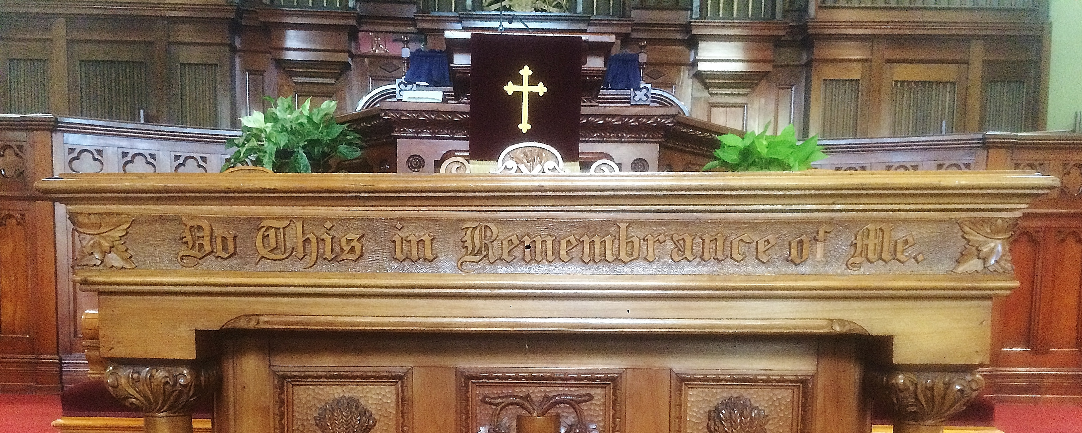
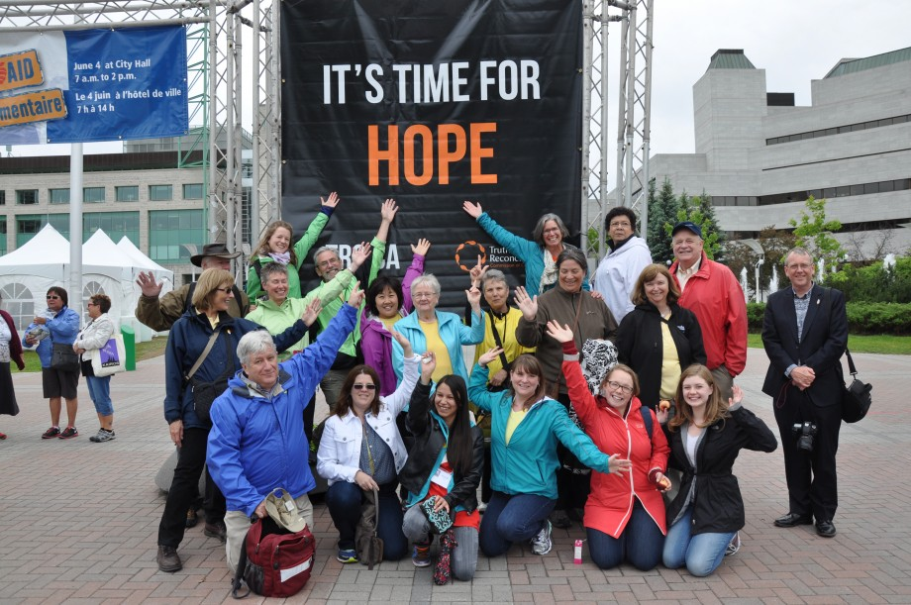

Allison Dyach
Sunday, July 25, 10:30 a.m.
Allison came from Knox Church Waterloo to worship with us while at Queen’s Faculty of Education. In June Allison attended the Truth and Reconciliation events in Ottawa as a representative of the Presbyterian Church in Canada. We will welcome Allison back to St. Andrew’s to share her reflections and our calling as Canadians and Christians. Elders Alberta Saunders and Larry Moore will lead us prayer.

Our minister returns from vacation with a series of sermons based on prayers for these days of summer.

‘Though the dawn breaks cheerless on this isle today, my spirit walks upon a path of light. For I know my greatness, Thou hast built me a throne within thy heart. I dwell safely within the circle of thy care …’
Sunday, August 2, 10:30 a.m.
The first prayer to be explored is by Alistair Maclean, steeped in the spirituality of the Hebridean isles. And all ‘who love the Lord a little and wish to love him more’ are invited to gather for Holy Communion.

‘O sweet and loving God, when I stay asleep too long, oblivious to all your many blessings, then, please wake me up, and sing to me your joyful song …’
Sunday, August 9, 10:30 a.m.
This morning we will be guided in worship by a prayer offered by Mechthild of Madgeburg (1207- 1282). We will also with joy gather to baptise Isla, daughter of Jonathan, in the name of the Father, the Son and the Holy Spirit.

‘Bring us, O Lord God, at our last awakening into the house and gate of heaven … ‘
Sunday, August 16, 10:30 a.m.
Our summer prayers continue with a contribution by the great English poet and cleric John Donne (1572-1631), reminding us of the larger frameworks of life.

‘i thank You God for this most amazing day: for the leaping greenly spirits of trees and a blue true dream of sky;
and for everything which is natural
which is infinite which is yes’
Sunday, August 23, 10:30 a.m.
A 20th century prayer is provided by the American poet e.e. cummings, an invitation into the spiritual discipline and delight of gratitude.

‘God of wholeness,
you have created us bodily
that our work and faith may be one …’
Sunday, August 30, 10:30 a.m.
And as our contemporary, in the English Wesleyan tradition, Janet Morley contributes our final summer prayer, helping us give voice to our need for ‘wholeness’ from the ‘God of wholeness’.
Also …

Syrian Refugee Relief
The St. Andrew’s giant pie sale and special June offering has totalled $2,355 that will assist churches in the Middle East extend care in the name of Christ to refugees in Syria and nations around. Please continue to pray for the people of Syria, and all refugees.

Summer Open Door
If you have friends visiting this summer, be sure to suggest a tour of St. Andrew’s – Annie and Chloe will have the doors open Tuesday to Saturday 10 a.m.- 4 p.m.

Queen’s Sidewalk Sale
St. Andrew’s will once again have a table as 10,000 students walk up and down University Street. Would you like to extend an invitation to students and accept a shift of two hours on Saturday September 11, 10 a.m. – 4 p.m.? Speak to the minister.

Wireless Access
Thanks to work by Changuk, the open wireless access offered by St. Andrew’s has been extended - next time you are at the church, you will find the password on the bulletin board, and while waiting for the service to begin, you will be able to locate that elusive bible verse or prayer online!

Local Mission Funds Available
Congregations within the Presbytery of Kingston have been invited to apply for one-time funding (from $1,000 to $3,500) for special initiatives that have an evangelism component. If you have any suggestions, please pass them on to the Clerk of Session by July 20.
Prayers for Summer

Creator of all, thank You for summer!
Thank You for the warmth of the sun
and the increased daylight.
Thank You for the beauty I see all
around me and for the opportunity to
be outside and enjoy Your creation.
Thank You for the increased time I
have to be with my friends and family,
and for the more casual pace of the summer season.
Draw me closer to You this summer. Teach me how I can pray no matter where I am or what I am doing. Warm my soul with the awareness of Your presence, and light my path with Your Word and Counsel.
As I enjoy Your creation, create in me
a pure heart and a hunger and a thirst for You. Amen.
*********
That we can glimpse you within creation
is a beautiful thought,
but also tells us that you desire to be seen,
to be found and known.
Open our eyes, Lord,
as we walk through this world,
feel the wind and sunshine,
see the majesty of creation
unfolding before our eyes.
Help us to see you.
Amen.
From the Desk of the Minister, 2015

The Days of
Summer

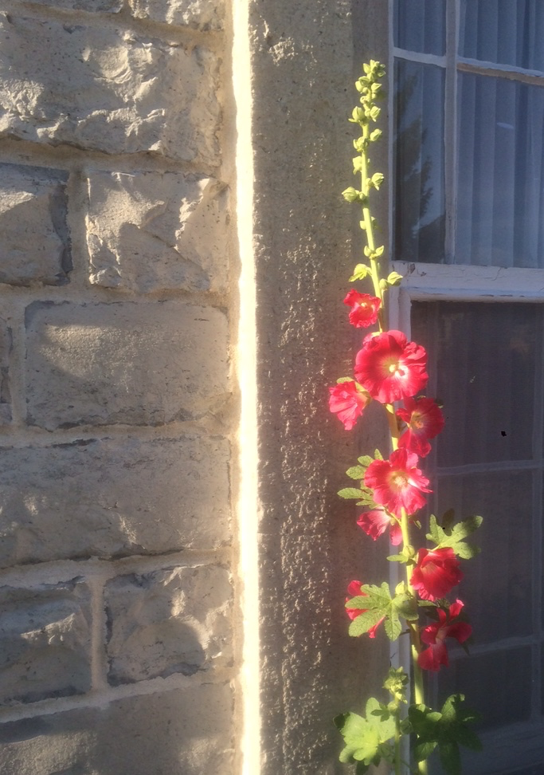

St. Andrew’s Church Kingston
The Presbyterian Church in Canada
www.standrewskingston.org

Join us

